PROJECT IN AUTOMATA AND LANGUAGE THEORY

GENDER NEUTRAL LANGUAGE RECOGNIZER

Submitted by:
Jasmine daÑO
Romavel Derita
Michaella Beltran
Genevieve Inojales

BSCS 3B

Submitted to:

ALMA MAE B. AUXTERO
Instructor

October 24, 2026

Project overview
NeutralLens is an offline Gender-Neutral Language Recognizer developed for the Automata and Language Theory machine problem. The application lets users open TXT, DOCX, or text-based PDF documents, extracts readable text, and identifies predefined gender-specific words or phrases. It displays each detected term, its number of occurrences, line location, and suggested gender-neutral alternative in a results table. The interface includes a document preview with highlighted matches, an overview dashboard, and report export options (TXT and CSV). Suggestions are provided for human review; original documents are not automatically changed.

Tools and recognition approach
The system is written in Python 3 using Tkinter and ttk for its desktop interface, python-docx to read Microsoft Word DOCX files, and pypdf to extract selectable text from PDF files. Recognition uses a deterministic finite automaton (DFA), implemented in dfa_engine.py. The DFA is constructed from the predefined vocabulary in terms.py as character-by-character transitions arranged in a trie-shaped state graph. A candidate is accepted only if its final state is marked accepting; nonexistent transitions move to an implicit rejecting state. The text scanner first identifies whole-word boundaries and phrase candidates, normalizes capitalization, then evaluates each candidate through the DFA.
Example DFA for the gender-specific term “he”:
State | Input | Next state / meaning
q0 (start) | h | q1: saw h
q1 | e | q2: saw he (accepting)
q0, q1, or q2 | unavailable transition | Rejecting sink (not a recognized term)

Simple transition diagram: q0 --h--> q1 --e--> ((q2)) [q2 is an accepting state]. For example, “He” is accepted after case normalization, while “the” is not recognized as “he” because the scanner sends whole words to the DFA rather than searching inside larger words.
A selection of 14 predefined terms and corresponding suggestions is shown below. The application contains additional entries in terms.py.
Gender-specific term | Suggested alternative | Gender-specific term | Suggested alternative
chairman | chairperson / chair | policeman | police officer
fireman | firefighter | stewardess | flight attendant
businessman | businessperson | salesman | salesperson
chairwoman | chairperson / chair | policewoman | police officer
waitress | server | mankind | humankind / humanity
cameraman | camera operator | manpower | workforce / staffing
he | they | she | they

Application screenshots
The screenshots below were captured from NeutralLens while using the supplied sample test documents. The application interface is shown with the currently selected file, the summary of findings, and the required message when no predefined terms are found.
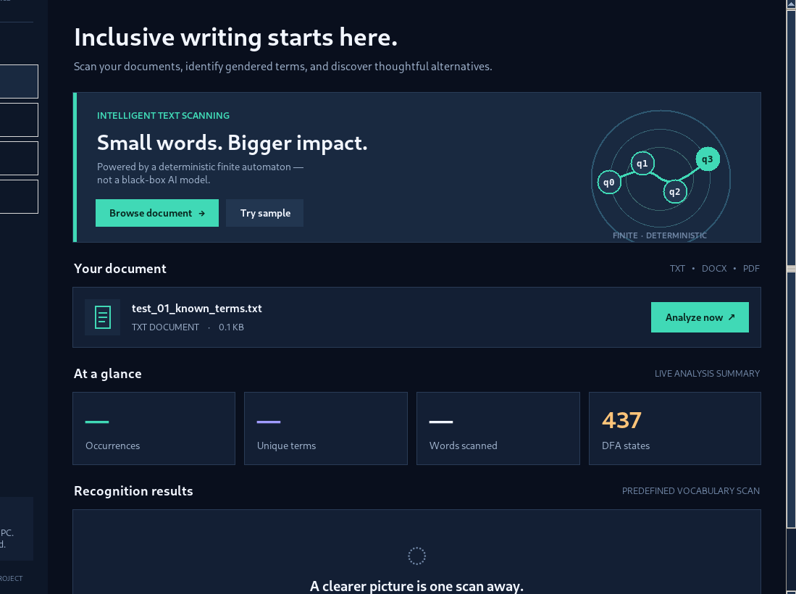
Figure 1. A TXT file selected in the Overview screen before analysis.
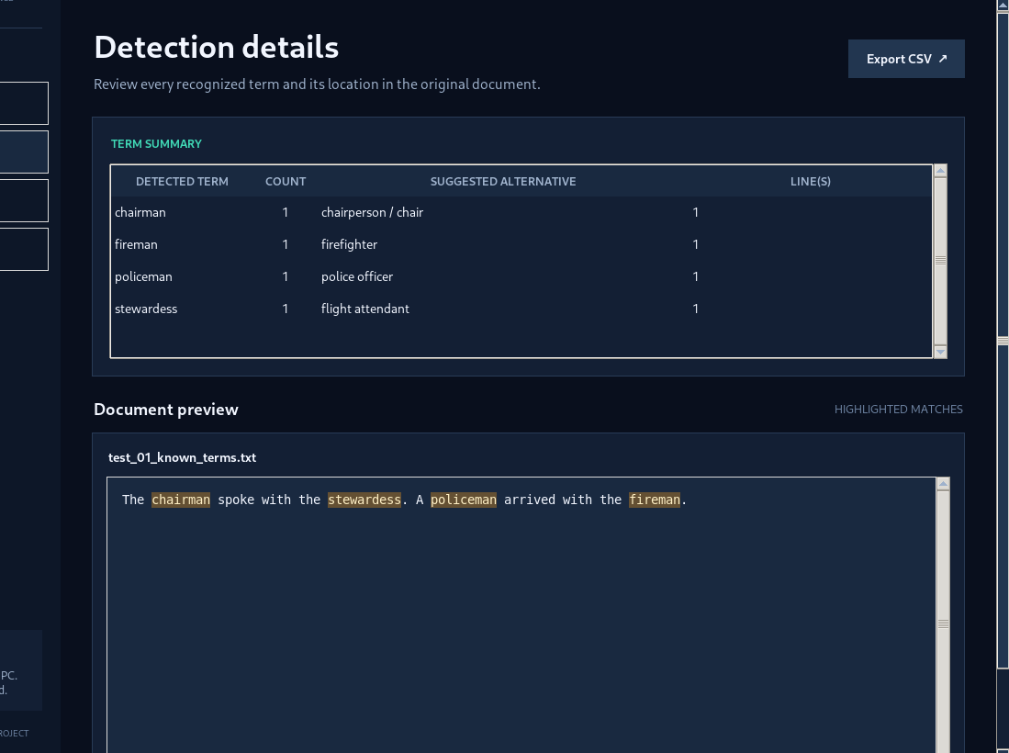
Figure 2. Four recognized terms with counts, suggestions, and highlighted document text.
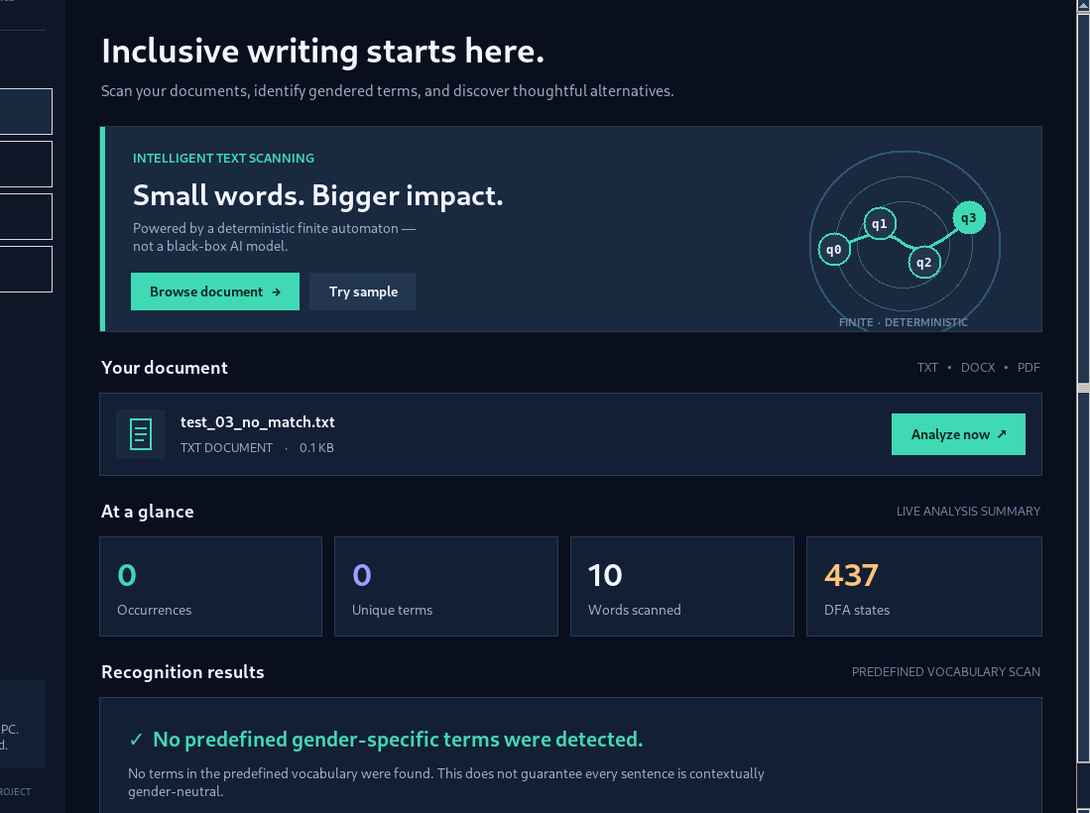
Figure 3. A no-match document produces the required no-detection message.
Source code: Included with the downloadable project ZIP. PUBLIC REPOSITORY LINK:
https://github.com/Jasmine-Dano/Gender-Neutral-Language-Recognizer/tree/0f031ab948fce283750d3c0e86c1477f08a38319/NeutralLens_GenderNeutralRecognizer

4. Testing
The five instructor-required cases were tested against the final DFA recognizer and document reader. The automated suite was executed using “python -m unittest discover -s tests -v” and passed all 11 tests (5 guide-specific plus 6 existing unit tests). The no-match, file-selected, and detection cases were also opened in the graphical application for the screenshots above.
Test case | Expected result | Actual verified result | Status
1. Listed terms | Identify supplied gender-specific terms | 4 detected: chairman, stewardess, policeman, fireman. | PASS
2. Repetition / case | Match the same term regardless of case; count each occurrence | 4 matches for “chairman”: Chairman, CHAIRMAN, chairman, chairman. | PASS
3. No terms / “the” | Zero matches; exact no-detection message; “the” must not match “he” | 0 matches; “No predefined gender-specific terms were detected.” “the” was not falsely flagged. | PASS
4. Empty TXT | Stop analysis and show clear “no readable text” warning | Empty file extracted as blank; GUI guards with “This document has no readable text...” warning. | PASS
5. Unsupported file | Do not process an unsupported extension; explain supported formats | A .dat file raises “Please choose a .txt, .docx or .pdf document.” | PASS

To reproduce: open the five labeled files in samples/ (test_01 through test_05), or run the automated tests from the project folder. The file readers also support DOCX and text-based PDFs, although the five compulsory cases use simple test files as specified.

5. Conclusion
The project produced a working desktop application that recognizes predefined gender-specific words and phrases using a character-transition DFA. It strengthened our understanding of states, transitions, accepting states, and whole-word matching while demonstrating practical document scanning and report generation. All five required situations passed automated testing. The approach is intentionally vocabulary-based: it cannot assess full grammatical or social context, it does not automatically rewrite files, and scanned image-only PDFs require separate OCR. Every suggested replacement should be reviewed by a person before use.

6. Sources and contributions
Tools and references: Python 3 standard library (tkinter, pathlib, re, unittest); python-docx for DOCX reading (https://python-docx.readthedocs.io/); pypdf for PDF extraction (https://pypdf.readthedocs.io/); and the supplied BISU machine-problem guide. The project uses an original vocabulary-driven DFA implementation in dfa_engine.py. OpenAI ChatGPT assisted with code generation, UI design, debugging, sample test creation, and preparation of this draft; the student group is responsible for reviewing and verifying the final submission.

Individual Contributions
- Jasmine Daño – Lead Programmer: Led the system development, designed the user interface, implemented the DFA, integrated all features, and handled debugging and testing.
- Michaella Beltran – Research and Documentation: Assisted in research, documentation, and report preparation.
- Romavel Derita – System Tester: Assisted in testing the application, checking its functionality, and identifying errors.
- Genevieve Inojales – Documentation and Presentation: Assisted in preparing project documentation and presentation materials.

